**Instructions for Google Docs Spreadsheet – Speed Reading Log & Chart**

1. Make sure you have a Google account (free). If not, create a free account at <https://www.google.com/accounts/NewAccount>.
2. Go to Internet Explorer and type <http://docs.google.com> into the browser window.
3. Next to **Create New**, click on the drop-down menu and select **Spreadsheet**.
4. In **cell A1**, write **Speed Reading Log & Chart** and **your name** (first and last).
5. In **cell A3**, write **Date**.
6. In **cell B3**, write **Reading Speed (wpm).**
7. In **cell C3**, write **Comprehension (%).**
8. In **cell D3**, write **Category**.
9. Each time you read, record the date, the reading speed, and the comprehension rate. See the example:

**Date Reading Speed (wpm) Comprehension (%) Category**

9/2/2010 200 70 business

9/7/2010 175 80 technology

9/9/2010 180 75 psychology

9/14/2010 190 75

9/16/2010 195 80

9/21/2010 200 75

9/23/2010 205 70

9/28/2010 200 80

1. Highlight the data you have in your spreadsheet, starting with cell A3 to cell C?
2. 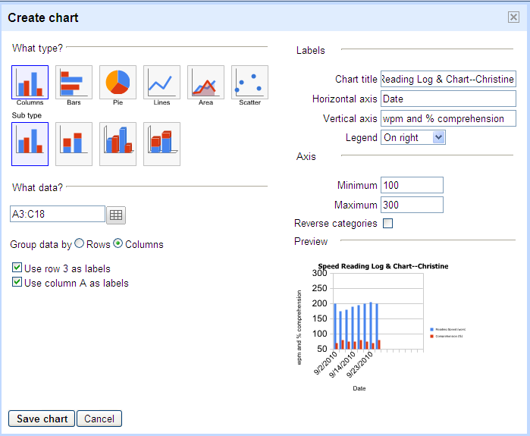To create a chart, click **Insert > Chart**.
3. Select a **bar graph** (columns) as the type.
4. Fill in the labels:
   1. Chart title: **Speed Reading Log & Chart—your name**
   2. Horizontal axis: **date**
   3. Vertical axis: **wpm and % comprehension**
   4. Axis:
      * Minimum: **100**
      * Maximum: **300**
5. For Group data by, click **Columns**.
6. Click “**Use column A as labels**.”
7. Click **Save chart**.
8. 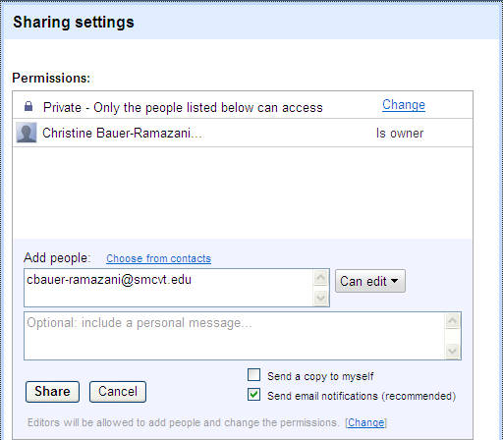To share the chart with me, please click **Share** (top right).
9. Click the box under **Add people** and type in my email address: [cbauer-ramazani@smcvt.edu](mailto:cbauer-ramazani@smcvt.edu).
10. Click **Share**. Do this each time you change/edit your chart.

[Sample Speedreading Log and Chart](https://spreadsheets.google.com/pub?key=0AjheyPQWfRyIdGxLUFJNNGdYZmNlcmNfYTU3QUEtakE&hl=en&single=true&gid=0&output=html):